What shot should I try to hit back as the ball comes toward me?

That depends on your skill level and where you are in the court. If you are a beginner, you are simply trying to get in back over the net and in the court. But intermediate and advance players often want to do more that just get it back in play. A smart coach told me many years ago to image that your side of the court is broken into 3 zones. The green zone (offense) near the service lines towards the net. The yellow zone (neutral) near and around the baseline. The red zone (defense) behind the baseline and/or near the back fence. As the ball crosses the net towards you, whisper or say silently to yourself that it is a green, yellow or red ball. That will mentally remind you what shot you could reasonable attempt to return. Often time players try to hit the wrong shot at the wrong time. This is called poor shot selection. Smart players go for the right shot at the right time for good shot selection to cut down on their errors and increase their winners. Remember to be patient during the point and wait for your opporunity to hit a winner. Don’t try to go for the winner until you have a high percentage green ball shot. This is a simple and easy to follow concept to help you remember which shot to try to hit when.

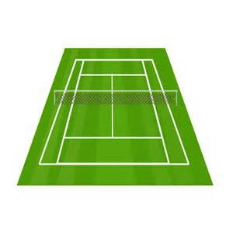
Green Zone (offense) is a ball you strike close to the net or in the service box. You should usually hit a winner or an offensive shot. You are in control.
Green Zone
Yellow Zone
Red Zone
Yellow Zone (neutral) is a ball you strike near the baseline. You should hit an offensive shot or a neutral shot.
Red Zone (defense) is a ball you strike from well behind the baseline. You should hit a defensive shot (deep and down the middle) or deep high lob (if they come to the net) to try to stay in the point. They are in control, don’t try to hit a winner

Think Red light, Yellow light and Green light (RYG)
or some people say Defense, Neutral and Offense (DNO)

Duane Smith AthensTennis.com

